MEDICAL INSURANCE COST PREDICTION
About the Data:
This dataset contains about 1500 rows with following features:
age: age of primary beneficiary
sex: insurance contractor gender, female, male
bmi: Body mass index, providing an understanding of body, weights that are relatively high or low relative to height, objective index of body weight (kg / m ^ 2) using the ratio of height to weight, ideally 18.5 to 24.9
children: Number of children covered by health insurance / Number of dependents
smoker: Smoking
region: the beneficiary's residential area in the US, northeast, southeast, southwest, northwest.
charges: Individual medical costs billed by health insurance
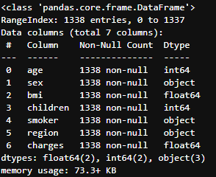
dataset information & sample rows
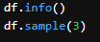



Observing Linear Independence
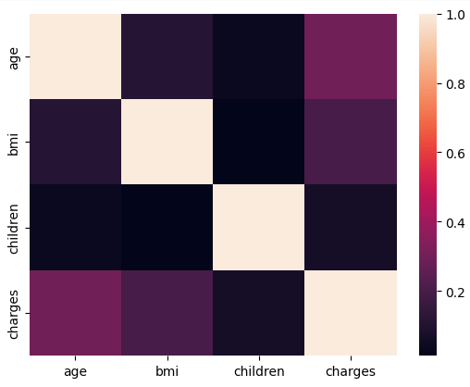
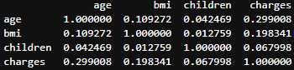
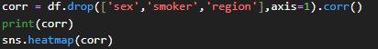
From the correlation matrix and heat map. It is observed that there is no or negligible linear dependency of some numerical columns .
But on the other hand it is found that the charges of insurance for an individual is slightly increase (corr b/w 0.19 to 0.3) wrt their age and bmi. Also the individuals smoking habits also influence their insurance bill.

Detecting outliars:
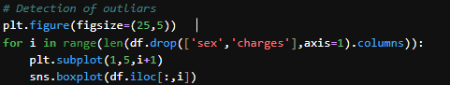
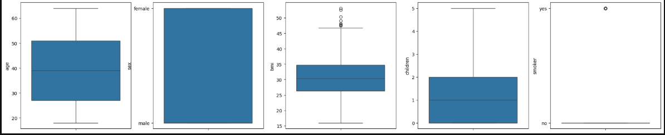
It is clear that the bmi feature contains outliers.
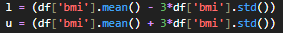
Since bmi is approximately normally distributed , we cap the outliers using a lb and ub

IMPLEMENTING ML REGRESSION ALGORITHMS
For this dataset I have implemented 5 different ML Regressors:
- Simple Linear Regression ;(pipe1)
- Elastic Net ;(pipe2)
- Elastic Net + Polynomials + GridSearchCV ;(pipe3)
- Decision Trees + Polynomials + GridSearchCV ;(pipe4)
- Random Forest + Polynomials + GridSearchCV ;(pipe5)
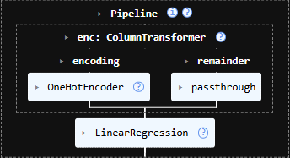
PIPELINES
Pipe1 –
Coefficients
-11743.907743711388,
[ -118.98897289 ,24101.51830894 , -387.72255754 ,-1089.42981176,
-1348.90405722, 252.72989303, 343.1359369 ,509.55283133]

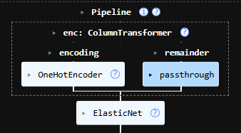
Pipe2 –
coefficents
-11761.01513384248,
[ -109.12157083, 24087.05458477 , -349.86618045, -1049.8862775,
-1310.51987106, 252.76376363 , 342.68390766 , 507.65311856]

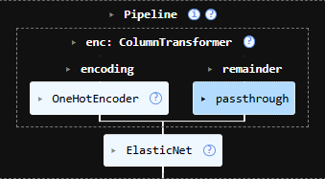
Pipe3 –
coefficents
13417.61110938223,
[ 0. -429.82056892 -8169.08124326 -27.84612867
1083.81896034 447.17133044 -1285.16816593 1945.03822346
1694.43513276 -0. -82.2058092 -120.90222716
-0. -228.9178142 263.55582097 325.14465399
-334.94289912 -0. -24.89057501 -291.53161615
197.5016422 -96.74031903 18839.90564772 -327.44789671
-179.11811245 0. 0. -0.
0. 152.76859742 0. 0.
1064.60581335 -2493.3778253 -163.44860402 61.94856959
439.0860021 -1153.66407551 -525.6561591 4650.84053659
-0. -306.82658924 -1599.0102718 206.07553345
-261.36677148]

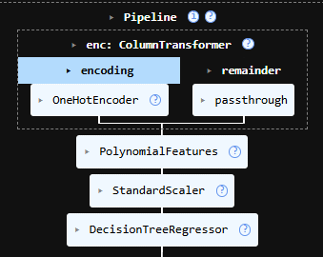

Pipe4 –

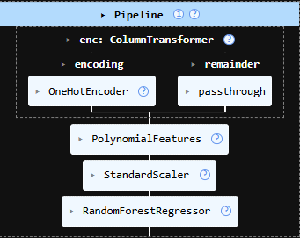
Pipe5 –

On fitting 5 (in which 3 are built using grid search cv) pipelines we get following r2 score on the training set
pipe1 | 0.7513729356955662
pipe 2 | 0.7513708328190322
pipe 3 | 0.8468935473046245
pipe 4 | 0.8670433884127282
pipe 5 | 0.8618181635254127
And on testing the r2 score on the test data(final_stage):
pipe1 | 0.7459239498191239
pipe2 | 0.7460399234903734
pipe3 | 0.8486939688398569
pipe4 | 0.8537345153392542
pipe5 | 0.859485816700263

OBSERVING ABOVE R2_scores
On observing the above two table of R2 scores one is of the training set and other is for the test set we have found that the initial two models are built assuming that that the data is linear, so the initial two pipelines assume that there is no polynomial interaction between the features while pipeline 3 is upgraded version of pipe2, we have included the polynomial features here so the pipeline 3 is nothing but the elastic net (pipe 2)) with polynomial of degree two so here we can see that there is a big increase in the r2 score that shows the features have non linear relationship.
Similarly we found that pipeline4 and pipeline5 has higher accuracy equals to pipeline 3.

Which model is better pipe3, pipe4 or pipe5?
Pipeline 3: The Pipeline 3 is implemented by using elastic net regression with polynomial features initially we have six input features but after the fitting of pipeline the input feature becomes 45 which is a mess because now we have 46 coefficients that makes interpretability of the coefficients very hard.
Pipeline 4: The pipeline 4 for consist of the model decision tree with best hyper parameters obtained from grid search cv as maxdepth 5 minimum sample leaf 30 minimum sample per split 70 and the best param for polynomial features degree equal to include bias equal to true that means it a feature with values 1
Pipeline 5: The pipeline consists of the model random forest Regressor with the best parameters using grid search cv as Max depth equaled five minimum sample per split equals 70 minimum sample leaf 30 And for polynomial features the hyperparameters are same as for pipeline 4
CONCLUSION:
On observing the pipeline 3, 4 and 5 we have found that pipeline 3 is complicated in interpretation Because it contains 46 coefficients that is not read but when we switched to decision trees even it produce best result or approximately same result at pipeline 3 and it is less complicated but while we have random forest and we know that random forest is nothing but collection of trees which performs much better than a single tree That’s why we proceed with the pipeline 5 as our final model
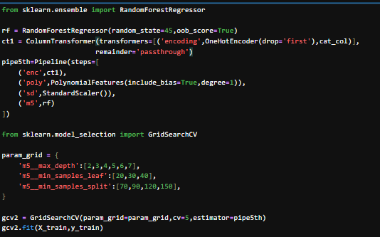
Let us see some features of model 5

Best hyper parameters:
{'m5__max_depth': 5, 'm5__min_samples_leaf': 30, 'm5__min_samples_split': 70}
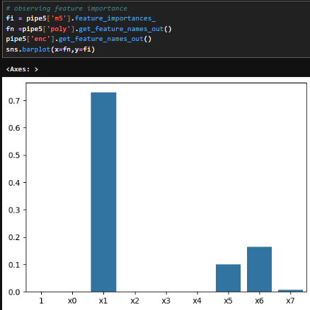
- Feature Importance:
On plotting the graph between X = pipeline’s last step’s inpu or the input that final model will take V/s Y= the feature importance .
We found that feature x1 influence approx. 70 % of model predication while feature x5 and x6 roughly influence 10% and 15 % .
So here we can say that feature x1,x5,x6 are most important for mode’s prediction .

What are feature x1,x5,x6
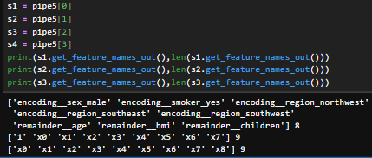
On observing all the steps of this pipeline we find that:
. x1 = smoker , .x5= age , .x6 = bmi
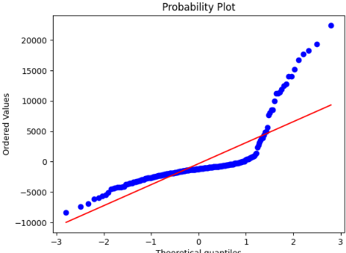
So , the age , bmi and smoking factor of an individual influence the price of health insurance
Observing Residual Plot by using pipe5
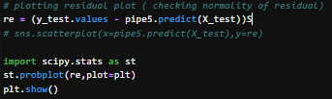
if we observe the residual plot we will find it is not perfectly normally distributed.
So to make it normal , I have done the following treatments.
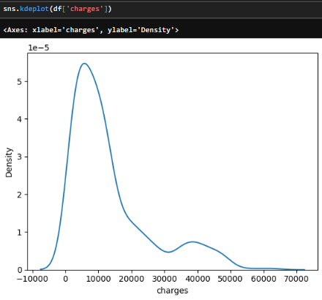
- I have plotted density of target variable (charges)

And found that is bimodal
- Then I have tried different-different transformations like log , box-cox,yeo-johnshon :
But it do not works
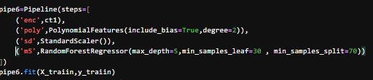
- I even made pipe6 which includes random forest and polynomial with degress(2)

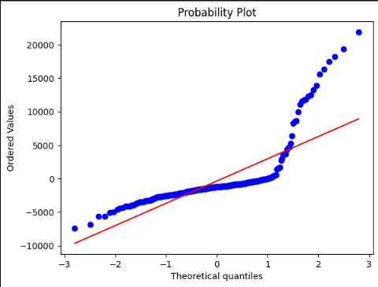
But again residual normality is not achieved.

Now, from the random forest feature importance we have found that smoker feature is explain about 70 % variability of y ie insurance charges.
ANALYSING charges (target variable)
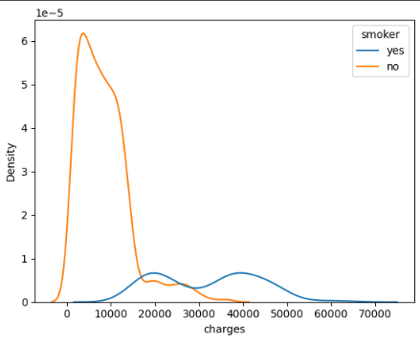
sns.kdeplot(data=df2, x='charges', hue='smoker') sns.boxplot(df2['charges'])
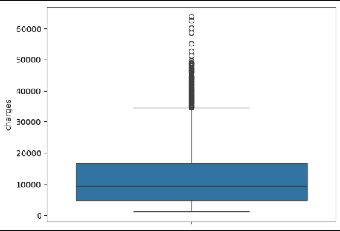

- From kde plot – we find that the target variable is bi modal and it comes from two different population (both mean and variance differ) while the non-smoker population is kind of normal but the smoker population is bimodal which creates the non-normality of residuals
- From box plot we can see that there are too many outliers in the target variable
Treating the outliers:
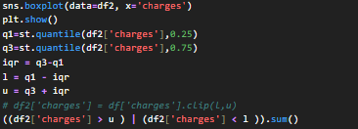
Now we found that there are 169 outiers that is approximately 13 % of the total data
On counting out of 169 ouliers how many are smokers
df['charges'][((df2['charges'] > u ) | (df2['charges'] < l )) & (df2['smoker'] == 'yes' )].count()
we found that 157 ie approx. 92%.
So outliers are not just random values they are important and they show that about 90% of outliers(high values) in Insurance charges are of those individuals who smoke.
Final Conclusion.
The final model selected was a Random Forest Regressor (Pipe 5). While linear diagnostics showed non-normal residuals, further analysis proved this was due to the bimodal nature of the population (Smokers vs. Non-Smokers) rather than model failure. By retaining the 170 'outliers'—92% of whom were smokers—the model maintained its ability to accurately forecast high-variance medical costs, which is the most critical requirement for insurance risk modeling

Your "Master's Level" Final Defense
If a professor or interviewer asks why your residuals are non-normal, your answer should be:
"The residuals are non-normal due to the bimodal nature of the target variable. Analysis confirmed that 92% of the outliers were tied to a specific latent class (smokers). I chose not to transform or remove these values because they represent a valid sub-population, and the Random Forest model was able to successfully capture this variance with a testing RMSE of 4560."

Final Model Recommendation: Pipe 5
Stop with Pipe 5 (Random Forest).
- It handles the bimodal split naturally.
- It doesn't require the strict normality assumptions of linear models.
- It generalizes perfectly (minimal gap between 0.861 and 0.859 scores).

RMSE for training and testing data.
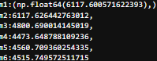
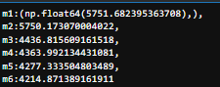

Project Conclusion: Predictive Modeling of Bimodal Healthcare Costs

1. Executive Summary
This project successfully developed a robust predictive framework for medical insurance costs, achieving a testing $R^2$ of 0.859 and a testing RMSE of 4560.71. The analysis transitioned from traditional linear models to an ensemble-based Random Forest (Pipe 5), which proved significantly more capable of handling the inherent non-linearity and multimodality of the dataset.

2. The Discovery: A Bimodal Reality
The primary challenge of this dataset was the bimodal distribution of the target variable, "charges".
- Group Segmentation: Visual diagnostics (KDE and Boxplots) revealed that the population is split into two distinct financial realities based on smoking status.
- Statistical Divergence: Non-smokers represent a low-variance, low-cost group (typically <15,000), while smokers represent a high-variance, high-cost group extending past 60,000.

3. Outlier Analysis and Integrity
A critical phase of the project involved investigating 170 statistical outliers identified by the 3-sigma rule.
- The "Smoking Gun": Diagnostic filtering proved that 92% of these outliers (157 rows) were smokers.
- Strategic Decision: I opted against "treating" or capping these outliers. Since they represent a valid and critical sub-population, removing them would have artificially improved residual normality at the cost of the model's ability to predict high-risk insurance claims—the most valuable function of the model.

4. Model Evolution and Performance
We evaluated multiple architectures, moving from simple linear baselines to complex pipelines.
Model Stage | Key Features | Testing RMSE | Result
m1/m2 | Linear & ElasticNet | ~6117 | High error due to bimodal data.
m5 | Random Forest | 4560 | Best performance; handled clusters naturally.
pipe6/m6 | Polynomial Interactions | 4560 | No significant gain over Pipe 5.

5. Residual Diagnostics
Despite high predictive accuracy ($R^2 = 0.86$), the Probability Plots (Q-Q) consistently showed non-normal, heavy-tailed residuals.
- Interpretation: For a Master's level study, this non-normality is interpreted not as a model failure, but as a direct result of the latent grouping (Smoker vs. Non-Smoker).
- Conclusion: The Random Forest correctly prioritized minimizing global error (MSE) over achieving Gaussian residual symmetry, which is a common trade-off when modeling mixed populations.

6. Final Verdict
The Random Forest (Pipe 5) is the final recommended model. It provides a stable generalization with nearly zero gap between training (0.861) and testing (0.859) scores. By leveraging the 70% importance of the smoker feature, the model accurately bridges the gap between the two distribution peaks without requiring biased data manipulation.

